# File permissions in Linux

## **Project description**

The goal of this project is to check the files and their permissions, and update them accordingly. The following permissions need to be adjusted

* Others need their write permissions removed on project_k.txt
* User needs their write permissions removed on .project_x.txt
* Group needs their write permissions removed, as well as their read permissions added on .project_x.txt
* Group needs their execute permissions removed on the drafts directory

## **Check file and directory details**

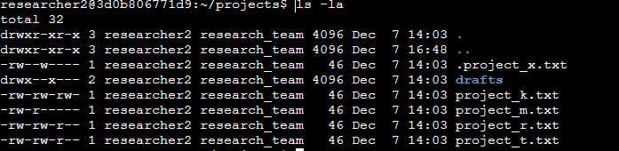

The command first used is **ls -la**. **ls** lists all files in the current directory, **-la** lists the permissions for the files listed as well as shows the hidden files in the directory as well. From the command we can see there are 3 directories and 5 files (including 1 hidden file).

## **Describe the permissions string**

A permissions string typically consists of 10 characters.

The first character is determined by the type of file (**d** for directory, **-** for a file)

The following strings of characters are different depending on the permissions that have been granted to a specific group. The types of permissions that can be granted are **R (**Read permissions), **W** (Write permissions), and **X** (Execute permissions). Read permissions allow the user to view specific files/directories, Write permissions allow the user to edit files or create new ones, and Execute permissions allow the user to run the file (typically an executable file). When a specific group does not have access to a certain permission, this is denoted with a hyphen (**-**).

In the permissions string:

* Characters 2-4 are determined by the permissions for the user
* Characters 5-7 are determined by the permissions for the group
* Characters 8-10 are determined by the permissions for other (anyone not included within the other 2 groups)

## **Change file permissions**

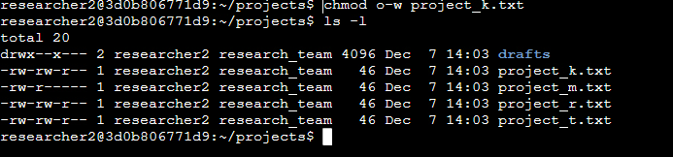

The command used first is **chmod o-w project_k.txt** . The **chmod** command adjusts the permissions for the specified group (in this case **o** designates Others) for the specific file (in this case **project_k.txt**). **-w** tells bash to remove write permissions from Others. The second command **ls -l** shows the updated file list with the write permissions removed from others on **project_k.txt** .

## **Change file permissions on a hidden file**

## 

The command used first is **chmod u-w, g-w, g+r .project_x.txt** . The **chmod** command adjusts the permissions for the specified group (in this case, users and group permissions) for the specific file (in this case .**project_x.txt**). **-w** tells bash to remove write permissions from users and group, and +r tells bash to add read permissions to group. The second command **ls -la** shows the updated file list (including hidden files) with the write permissions removed from user and group, and read permissions added to group on .**project_x.txt** .

## **Change directory permissions**

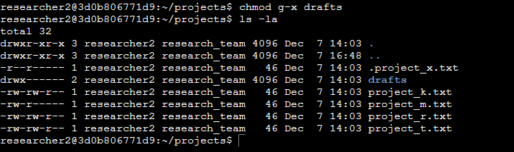

The command used first is **chmod g-x drafts**. The **chmod** command adjusts the permissions for the specified group (in this case **g** designates Group) for the specific file or directory (in this case the **drafts** directory). **-x** tells bash to remove execute permissions from group. The second command **ls -la** shows the updated file list with the execute permissions removed from group on the **drafts** directory.

## Summary

Through the use of the **chmod** command, permissions can be added or removed from a plethora of files or sub directories within the Projects directory. Usingthe **ls -la** command allowed viewing of files (hidden and regular) as well as their permissions to adjust as needed.